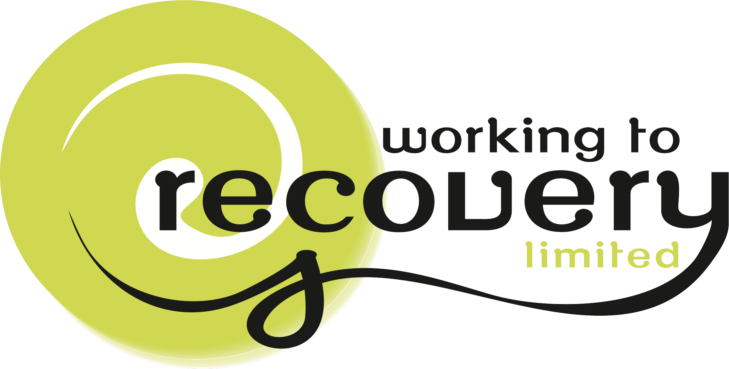

Creating Safe Places for Recovery

A one-day workshop
The Day
In this one-day seminar Karen & Alison will explore their experiences of running Crisis and recovery houses. There is much interest at the moment of how we can create alternatives to hospital admission and treatment. During the morning they will share their experiences, what worked – the afternoon will be exploring in groups what they would envisage the perfect safe space for recovery could be. Alison ran the very successful Anam Cara for 7 years a crisis and recovery service in the 1990’s in Birmingham, much lauded in the mental health foundation Crisis project workbook and reported in the Guardian

Karen has been involved in setting up different types of recovery houses starting in Gloucester in 2001, currently Houses based on her work with partner Ron Coleman are running in Perth WA, Trieste Italy and Amitola Communities in York UK. Karen has also run residential Five-day workshops where people can explore recovery and make leaps in their recovery as well as Recovery camps, she also regularly uses aids like Skype to walk alongside someone on their recovery journey, creating environments where recovery can and does happen.

The Trainers Karen Taylor

Karen Taylor was an RMN with 16 years experience in the NHS in England. She has personal experience of designing, implementing and managing innovative community care services. After leaving the NHS, she has worked with her husband ~Ron Coleman bringing the hearing voices approach to many Countries including Italy, Australia, NZ, France, Hong Kong, USA and Canada. She put all her experiences into running recovery house projects, all her learning on working with psychosis is rooted in practice and living with a voice hearer for over 20 years. Recovery from psychosis is possible for everyone, people can learn to understand their experience and move on. This should be a human right for anyone given this label. Karen is experience in working with families and believes real healing happens when dialogue happens. Karen has co-authored the workbook, ‘Working to Recovery’ and has also been involved in introducing recovery training into Australia, New Zealand, Palestine, Denmark and Italy as well as throughout the United Kingdom

Alison McCabe

Alison McCabe comes from a background of developing creativity through her life. In her thirties she was the Project Manager for an innovative user led mental health service called Anam Cara Crisis House based on Soteria house in California. It was a pioneering project that widely influenced other services globally. From this she went onto being a professional storyteller and developing arts programmes in school and the community. After completing her BA and a distinction in creative writing Alison continued to dedicate most of her time to developing creatively, working in a hospice setting for a number of years. The opportunity to become an apprentice in sacred sound came along at exactly the right time in her life. It has really opened up her voice and many healing dimensions of sound and silence. Alison is broadly on a Mystical Christian path though deeply honoring of all religions. She was born and grew up in South Africa under Apartheid and her passion for justice, equality and peace runs very strong as a theme through her life and work.

Who should attend

Suitable for commissioners, mental health service managers and staff, Housing support managers and staff, mental health workers, community development workers, social care staff, family members, allies, and people with lived experience, peer workers

