Smart1+
Installation Instructions

Boat Monitoring Systems by Digital-Guardianage Ltd
April 2020
Table of Contents
1. SAFETY 3
2. PRINCIPLES 3
3. SMART1+ 4
4. BEFORE YOU START 4
5. CONNECTIONS 5
6. PRE-INSTALL CHECKS 6
7. INSTALLATION 7
8. WIRING DIAGRAMS 10

SAFETY

Smart1+ must be fitted by a suitably qualified electrician who should turn off the circuits Smart1+ will connect to prior to installation.

Smart1+ remote switching capability should only be used to power up / power down a 12v / 24v circuit.

If removing wires from switches to test ensure you take appropriate precautions to protect against shorting

The wires from Smart1+ may be extended. However, ensure that wires are of the same gauge or larger. It is the installers responsibility to use the correct wiring protocol to keep the boat electrically safe. Any extended wire must be capable of sustaining more than three amps constantly and not be longer than three meters.

“T” connectors or other secure means to splice to connecting wires must be used. Twisted and taped connections are not a professional standard and if used, will void the warranty.

There are two voltage variants of Smart1+ 12v and 24v. You must ensure that Smart1+ variant matches the boats voltage. If the wrong variant is fitted the unit will be damaged and the warranty will be void. The unit contains an internal voltage data logger to show over voltage on the supply rail.

PRINCIPLES

Smart1+ has a simple design ethos and from just three input connections it can monitor the following:
- Domestic Battery Voltage
- Bilge pump activity
- Shore power
- zero volts entrance alarm and optional microwave sensor
- Current ambient temperature in the vicinity of Smart1+
- 0ºc frost temperature warning.
- auxiliary relay output (12v/24v) for driving larger loads.

SMART1+
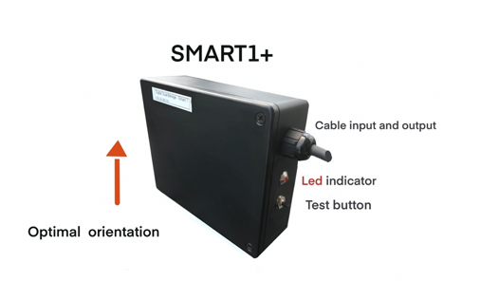Figure 1

BEFORE YOU START

For smart1+ to continuously monitor a boats’ systems, power to the bilge switches must be maintained, even when battery isolators are switched off.

If the relay function is not going to be used, you should isolate the ends of the relay output wires from Smart1+ (red and black with a blue sleeve) with tape or terminator fittings. Smart1+ must only be used to power up /power down 12v / 24v circuits.

Smart1+ contains an internal GSM antenna. For optimal reception this should be vertical. To achieve this the Smart1+ should be installed in the orientation in Figure 1 above. Smart1+ will operate in any other orientation, but this will be less optimal for mobile signal reception. Ensure that the unit is positioned so that you can see the red LED as this is used both as a commissioning / diagnostics tool.

In most boats there is usually sufficient room to install Smart1+ near the bilge switch(es) and allow the antenna to pick up a strong GSM signal. Irrespective of install location, the thicker, fused, red wire on Smart1+ must connect to the constant 12v / 24v uninterrupted power supply providing constant power to the bilge switch(es).

When installing Smart1+, try to avoid any 240v cable runs as this can cause GSM signal interference.

You must register the SIM card included with Smart1+ with our mobile telecoms’ provider. Details of the SIM card (numbers etc) are on the card included with your Smart1+, or alternatively you can visit their website :-

https://www.globalm2msim.com to test the unit. See instructions for guidance.

See also our guide on how to register and maintain credit on your SIM.

CONNECTIONS

The Marine Wiring Standard dictates a dedicated power supply coming directly from one of the batteries – usually the domestic / service batteries. This is to ensure safety critical items including the VHF radio and bilge pump/s can be used even if the battery isolator fails or is accidentally turned off. Normally this supply is always live via a fuse or breaker.

The placement of the bilge switch(es) vary by vessel type, for example, on a motorboat; the bilge switch or switches will be on or near the helm position(s) and on a yacht it will most likely be near the chart table control panel.

To monitor the activity of a bilge pump, Smart1+ must be connected to an auto / manual bilge switch, without such a connection, it cannot give bilge pump activity warnings. Some older yachts may not have an automatic bilge pump, relying only on a manual switch. If you want Smart 1+ to alert you of bilge pump activity you will need to retro fit an automatic float switch in the bilge and replace the original manual switch with a manual / auto / off / switch.

Typical layout of auto / manual bilge switch and Smart1+.

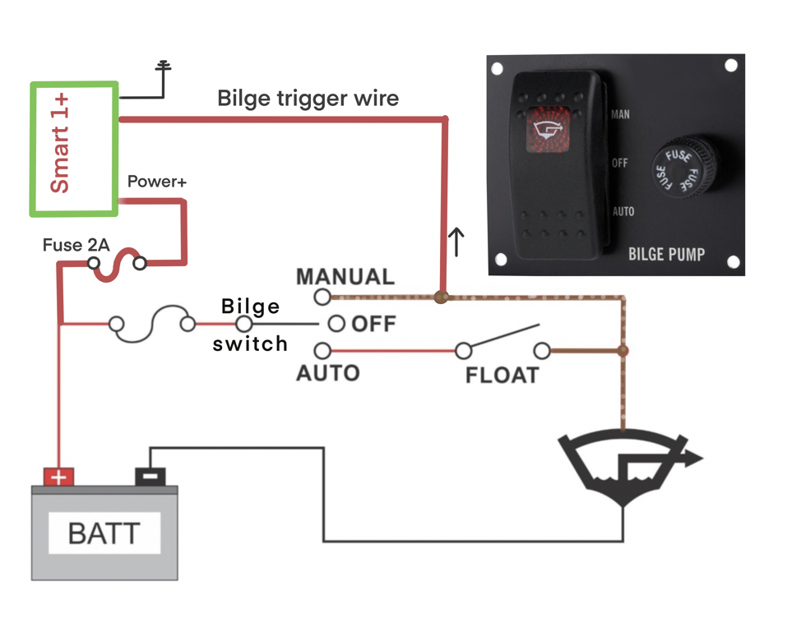Figure 2

PRE-INSTALL CHECKS

Prior to installation you will need to identify and mark the following:-

- A circuit to provide power to Smart1+,
- +ve and -ve* bilge-trigger cables
- A common -ve circuit

*NB the bilge - trigger black -ve wire, with yellow sleeve, can connect to any convenient 0v circuit in the close proximity of Smart1+

- Smart1+ must be connected to a constant, fused, power supply directly connected to the boats’ batteries (see point 4) via the bilge circuit. To identify the circuit to provide power to Smart1+ identify the wire connected to the bilge switch connected to the constant live power.

Note; colours often vary from manufacturer to manufacturer so ensure you use the appropriate tools to identify the live +ve (constant) feed.

Mark this cable “Bilge Power” ideally using red coloured tape or zip tie as this will match the colour convention on the fused Smart1+ power input cable. On boats that only have auto / manual switching the wire that stays live all the time when you toggle between the two states will be the “Bilge power”.

- To identify the bilge trigger wire (+ve), turn the bilge switch on to the manual position noting that it may be a press and hold function (momentary touch non-latching). Identify the wire that has now become live (battery voltage) and the pump should run. Mark this wire “bilge trigger +ve” ideally using yellow tape or zip ties as this will match the colour convention on Smart1+.

- The bilge trigger wire (-ve) on Smart1+ (black cable yellow sleeve) can connect to any common -ve circuit in close proximity of Smart1+.

- NB There is a single black cable connected to Smart1+ ie it has no coloured sleeve. This is the -ve common input for Smart1+. When considering your installation, note that this single black cable can also be spliced to the bilge trigger wire (-ve) identified in point 3 above.

NOTES:

- For flybridge boats it is not recommended to install Smart1+ on the upper helm as the lower helm is likely to offer more accessibility and easier cable routing.
- For steel vessels, you should consider installing Smart1+ in a good signal area and extending the leads*.

*cable lengths of up to 3m can be added without significant voltage drop. Cable lengths longer than this will affect the accuracy of the voltage measurements

INSTALLATION

Smart1+ is supplied with three pairs of trailing cables with different coloured sleeves:-

Yellow Bilge / Battery / Shore power
White Intruder
Blue Remote switching

Getting power to Smart1+ (fused) red wire (and unsleeved black wire))

Prior to making any electrical connections to / from Smart1+ ensure that the circuit it is being connected to is powered down if possible.

Connect the single red wire (with a fuse) from Smart1+ to the power supply cable identified in 5.1 above. Connect the single unsleeved black wire from Smart1+ to the common -ve circuit. Note this can be combined with the bilge -ve circuit.

Smart1+ Bilge, circuit – (red and black wires with yellow sleeves)

The connections from Smart1+ to the bilge circuit are the red and black cables with yellow sleeves. Note, at this point of the installation you can also connect the single black -ve cable from Smart1+ to the boats common -ve circuit. Splice into the cables with suitable connectors as follows :-

Red. Bilge Trigger(+ve) connects to wire identified in 5.2 above.
Alternatively this can be connected to +ve bilge alarm cable if present
(usually on boats with multiple pumps).
Black. Bilge Trigger (-ve) connects to a common -ve circuit nearby

Notes :-

- The manual switch wire that goes live when the bilge switch is operated by the float switch, or is manually triggered, may be connected to a warning light and / or a timed (usually 30 seconds) delay buzzer. Therefore to test Smart1+ hold the button for more than 30 seconds and then manually lift the float switch for more than 30 seconds.

- There is a 25 second delay before Smart1+ sends a warning text when either triggered manually or by the bilge float switch, this is to help eliminate false triggers / short “spurts”.

- Most motorboats have multiple bilge pump switches that in general link to a sounder and warning lights circuit. This is the preferred circuit for the Smart1+ bilge trigger (+ve) to connect to, as it will react to activity of any of the pumps. However, note that Smart1+ will be triggered when a bilge pump has been running for 55 seconds due to the 30 second delay timer on the bilge alarm.
- If there is no combined alarm with multiple bilge switches, then Smart1+ should be connected to the circuit of the lowest bilge pump in the boat, usually in the engine compartment, note that Smart1+ only reacts to the triggers created by that bilge circuit.

- In the absence of a common alarm for multiple bilge pumps, we have designed a very simple modification (not included). This will enable Smart1+ to monitor all pumps, by connecting diodes to all bilge switches. The circuit diagram can be found at the end of these instructions.

Intruder alert – red and black wires with white sleeves:

The door entry function is a zero-volt-normally-closed circuit triggered by the included magnetic reed sensor and puck. The wires from Smart1+, with the white sleeves, should be connected to the supplied reed sensor. Connections are not polarity sensitive.

Firmly attach the reed sensor to a suitable point in the entrance to the boat – usually a door frame - and attach the puck to the entrance door. Ensure that, when closed, the arrows on the puck and magnetic sensor line up. When closed the puck and sensor should be a close to each other as possible.

Optional wireless sensor

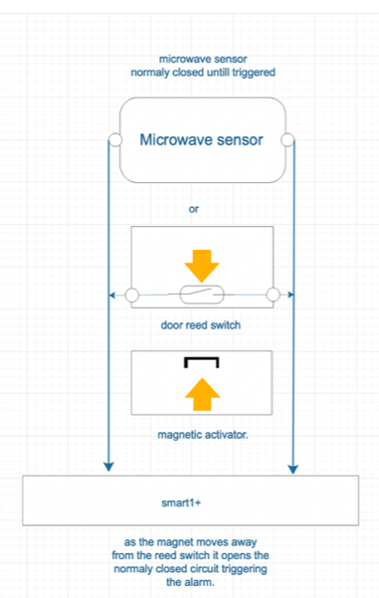
The simple reed switch may not be feasible for some boats. A microwave sensor is an optional extra.

This wired sensor can penetrate thin wood and GRP, is powered from the same source as Smart1+ and must be protected by a 1a fuse (not supplied). Power consumption is 22ma @12v or 11ma @24v.

The connections to Smart1+ are the same as for the reed switch. Only when a human body interrupts the microwave beam pattern will the sensor trigger - heat, wind and insects will not create a false trigger.

You will need to experiment with the sensitivity settings – see separate instructions included with the sensor – to ensure that you only capture movement on the boat.

The range and direction of the sensor can be adjusted up to 6m but this can be affected by its location and density of any obstacles in its way.
Figure 3
Remote relay circuit– red and black wires with blue sleeves:

With the optional relay, Smart1+ can power up 12v or 24v circuit. However, if this function is not to be used, protect the ends of the wires of Smart1+ with tape or terminator fittings. This ensures that the relay output wires from Smart1+ do not short and damage the unit.

The optional relay supplied is fully compatible with Smart1+. If a relay is retro fitted the, the relay coil must not exceed 350ohms or 500ma. A relay that exceeds these parameters will damage Smart1+ and void the warranty. The unit contains an internal voltage data logger to show over voltage on the supply rail. See figure 1 below.

For higher load switching, a high current relay (not included) must be driven either by the optional relay or any other relay (not included) but with a relay coil not exceeding 350ohms or 500ma. See figure 2 below.

For safety reasons, under no circumstances should Smart1+ be used to power up a circuit exceeding 12v or 24v.

Note. Smart1+ has a built-in failsafe that automatically turns off the relay if battery voltage drops below 12.2v or 24.4v. This is designed to reduce the power drain on the batteries. Note that Smart 1+ will not act on any texts to power up the relay until battery voltage exceeds 12.2v/24.4v.

Figure 4 Figure 5
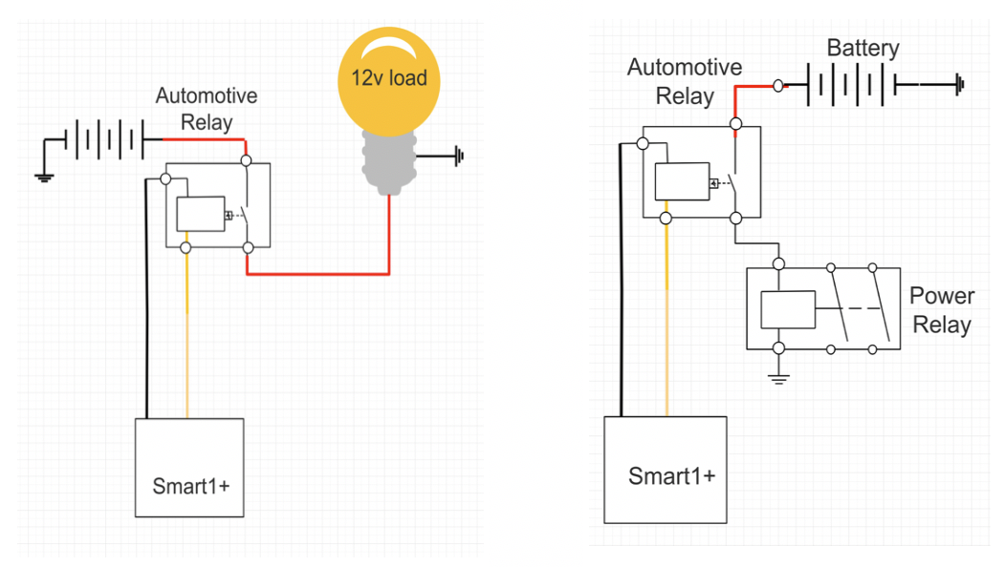

After commissioning Smart1+ you must perform a hard reboot by disconnecting it from its power source and reconnecting it. The easiest way to do this is to unscrew the black fuse holder on the large red wire and re connect it. Once installed correctly the red LED on Smart1+ blinks approximately every five-seconds.

WIRING DIAGRAMS

Smart1+
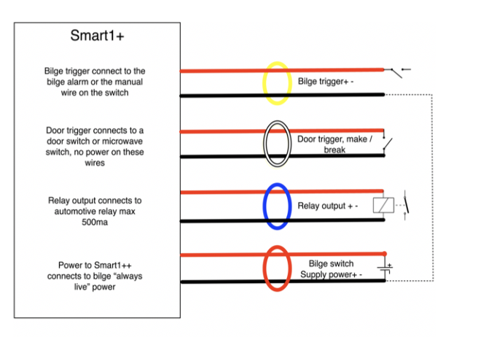
Figure 6

Optional microwave sensor

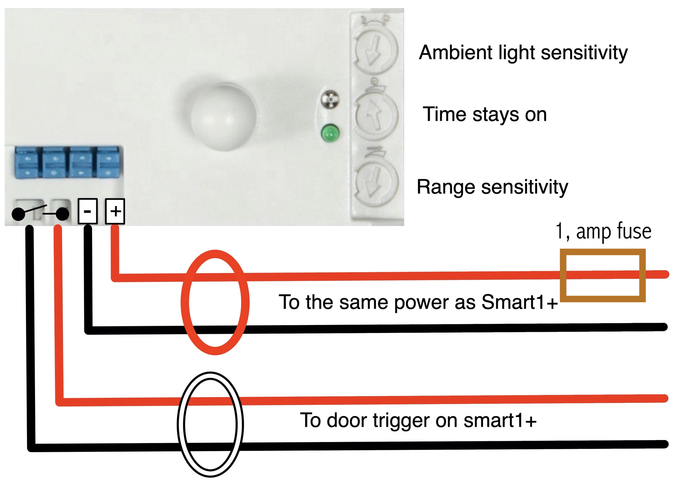
Figure 7

Suggested Diode upgrade

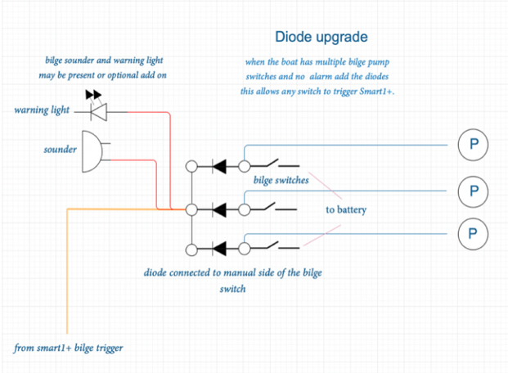
Figure 8

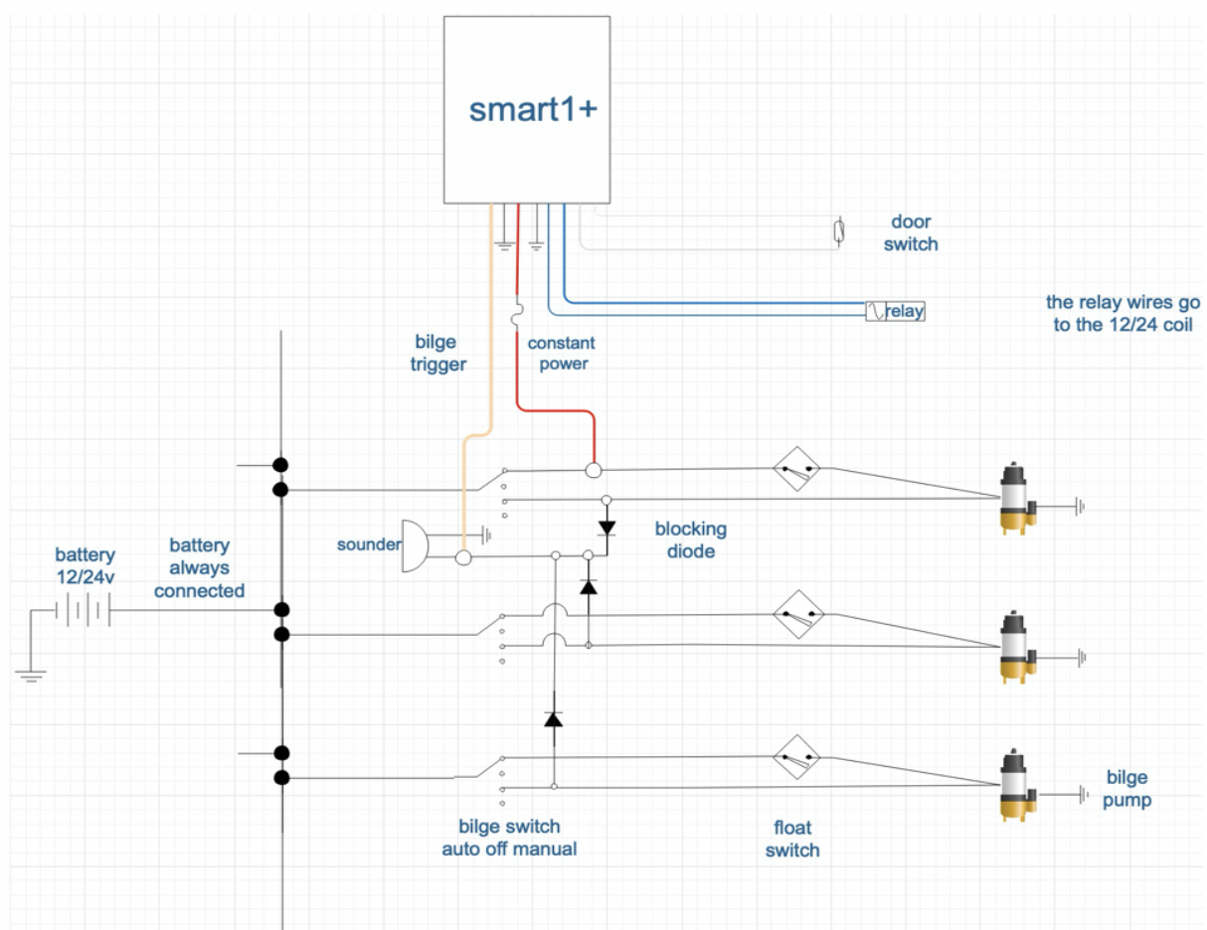
Figure 9

