Smart1+

Registering and topping up your SIM card.

User Instructions

Boat Monitoring Systems by Digital-Guardianage Ltd
April 2020

Table of Contents
1. INTRODUCTION 2
2. REGISTERING YOUR SIM CARD 3
3. Managing your account. 4
4. Topping up your SIM 5
5. Smart1+ Instructions for use 6
6. Command Summary 9
7. Decision logic in the event of a text alert 10
8. Tems and conditions 12

INTRODUCTION

Congratulations on the purchase of Smart1+. We are sure it will give you peace of mind as a boat owner, and that its features could help save you money.

Part of Digital-Guardianage Ltds’ philosophy of “keep it simple” also extends to the SIM card included with your Smart1+ device. You are not locked into a monthly contract as it is simply a Pay as You Go Sim card that you control.

Before you are able to use Smart1+ you must register the SIM card in your name with our telecoms partner Global M2M Sims. Our partner adds £2.00 (Inc VAT) of credit to each SIM card which will be more than sufficient to cover the costs of texts to commission your device.

At the time of publishing this guide texts from Smart1+ cost £0.07p + VAT per text, but please refer to Global M2M Sim website for their latest tariff. Check with your own mobile phone provider for costs of texts from your mobile device to Smart1+, in most cases they are free or as part of a bundle,

This guide will take you through the steps you need to take to register the SIM card, maintain its credit and provide you with instructions for Smart1+.

You must register your SIM before you are able to use Smart1+

If you are the installer you will either have to complete the registration of the SIM on your clients’ behalf, see section 2, or ask your client to do it. You will not be able to test the functionality of Smart1+ until a registered SIM card has connected to the local network.

REGISTERING YOUR SIM CARD

The SIM card in your Smart1+ is supplied by www.Globalm2msim.com. Included in the packaging is a credit card sized SIM wallet that contains all the information required to register the SIM card.

Setting up an account

Go to www.globalm2msim.com <log-in> or <register and activate your SIM>

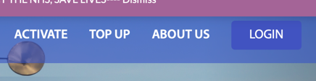
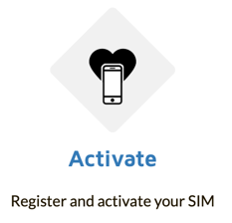

You will be taken to page to <create account>
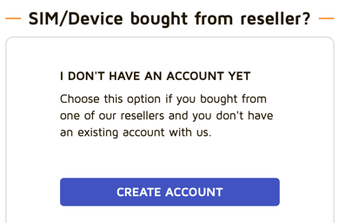

Complete all required details noting that all inputs will be editable in future with the exception of “First Name” and “Last Name”. If you think you will sell your boat in the future with Smart1+ still connected we suggest a generic name such as “Beneteau” and “Oceanis”.

Make a note of the password and e-mail used as these will be your log-in details when you want to manage your account

Check the “Terms and Conditions” box and <continue>

You will receive an e-mail from “GeoSIM Global M2M SIM” asking you to complete your SIM registration. Alternatively, you can go straight to the website to complete the registration process.

Click the <link> in the email or go to the “activation page”

From the “ACTIVATE GeoSIM” page:-

- Click <No> to “did you buy your SIM from this website”.
- Enter the SIM card ICCID number. This 19-digit number can be found on the white card contained in the SIM wallet.
- Enter the primary phone number (SIM MSISDN). This number can be found in your pack or on a sticker on the device.
- Tick “I am not a robot” and complete any “captcha”
- Click <continue>

If you are taken to the next page all is good however, if the numbers clear from the ICCID tab, there is likely an input error. Re input the numbers.
Note. There are two phone numbers, primary, and secondary, make sure you enter the primary at this stage. We will use the secondary on the phone messaging.

If details entered are correct you will be taken to the “My Sims” page

Managing your account.
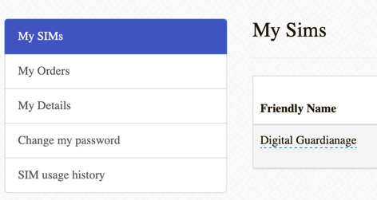
From the “My Sims” page you can edit most of the information you entered when you set up the account – this is done in the “my details” screen.

This is where a new owner of your boat can enter their details if you sell it with Smart1+

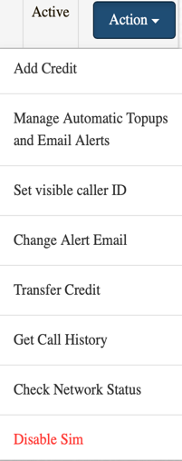
Other settings can be accessed using the “Action” button

Any changes made in these menus will not affect the operation of your “Smart1+”, is for administration only.

“manage top ups” sets the “auto email” function when the credit is running low. We do not recommend auto top-ups.

“Call History“ allows you to view the SIM activity. Note that the latest data is up 23.59 the previous day.

You will not lose your credit if you do not top up, it will stay on your account for 18 months then you will be given notice of inactivity before any action is taken.

M2M has a good help desk if you have issues setting up the SIM. If you need to call them quote Digital-Guardianage as the sim is designed for our product.

Topping up your SIM

You will receive an e-mail informing you of the need to top-up when your balance reduces to £1.00 or higher, if you set an email alert at more than £1.00. See 2.b. To top up, click the link in the e-mail or access the website directly

Click <Top-up> and the radio button next you your name and <continue>

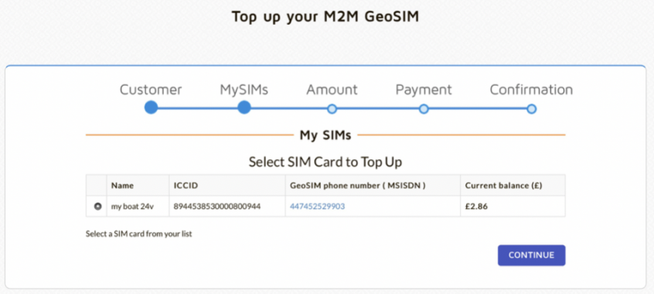
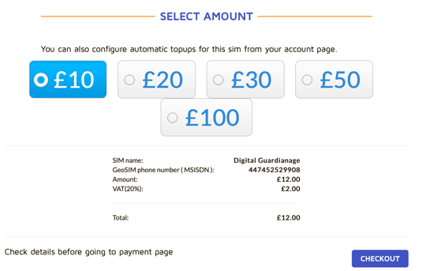

Select the amount of top up you require noting the minimum £10.00 and excludes VAT. Click <Checkout>.

You will be taken to the payment page for you to enter credit card / PayPal details. Once your payment has been cleared your top up is complete.

NB. Depending on how regularly you “ping” your Smart1+ £10.00 should be sufficient as at the time of publishing texts cost £0.07p from Smart1+

Smart1+ Instructions for use

Now you have registered the SIM card, it’s time to take control of Smart1+ and all its features. Ensure your installer completed a hard reboot of your Smart1+ after the initial power up. Once rebooted Smart1+ is ready for use.

First operation

You need to establish duplex (2-way) communication with your Smart1+ device. This is achieved by texting “hello” (not case sensitive and excluding the “ “) to the primary or secondary number in your pack. You should receive a response from Smart1+ within 30 – 60 seconds, depending on the network.

If, when setting up for the first time you do not receive a message within five minutes send a “hello” text to the other number in your pack.

The “hello” command links your Smart1+ to the phone that sent the text, and it will only send texts to that phone. Smart1+ can only be linked to one phone at a time.

Note that any phone can send a text command (other than “hello”) to Smart1+ but only the phone that sent the last “hello” text to it will receive the response.

If you want to transfer control of your Smart1+ to another person they should send a “hello” text from their phone to your Smart1+ primary number and they will receive a message saying “your contact details have been updated”

If the external red led is flashing every five seconds or so it has made contact with the network if its solid red it has not made contact - wait until it has.

An “enable” text to Smart1+, will commence its monitoring function and a disable text to Smart1+ switches off all the monitoring activity.

NB even though the unit is not monitoring your boats systems it is still powered up ready to receive further texts. The ‘enable” text reinstates Smart1+ monitor to full system activity.

A “ping” text interrogates Smart1+ to ascertain battery voltage, bilge activity, shore power, temperature and occupancy, plus auxiliary function state.

Remote Switching

Smart1+ must not be used to power up a 240v circuit, it must be limited to 12v / 24v circuits.

To power up a circuit texting “aux on” to your Smart1+. Note, that the circuit that is remotely powered up can still be manually switched off however, Smart1+ will not be aware of this manual over-ride. Therefore an “aux off” command will need to be sent to Smart1+ to reset Smart1+.
Battery Warnings

Smart1+ triggers three battery warnings when parameters are triggered.

- Over-voltage. When battery voltage exceeds 14v / 28v for 14 hours consecutively. When a charger is in “float mode” voltage should be no greater than 13.8v/27.6v, if it exceeds this level, it is an early warning that your batteries may have a problem and will need investigating.

- Low voltage. This is sent at 12.2v / 24.4v and automatically powers down any 12v / 24v remote relay system previously powered up by an “Aux on” text. This will preserve your batteries.

- Critical voltage. A final text is sent if voltage reduces to less than 10.8v / 21.6v. Smart1+ places itself into low power mode (to preserve battery charge) until the voltage increases above 13v / 26v. NB. Smart1+ will not be capable of sending or receiving texts when in low power mode.

Other Commands

Smart1+ has an internal temperature sensor and the ambient temperature around the unit will display on a “ping” response. Smart1+ will text a warning at 0 degrees c and a further text when the temperature increases above 0c.

Should you only use solar panels (and no shore power) we recommend disabling shore power warnings. The “solar” command will stop this warning when the sun sets. You will need to check the battery voltage via a “ping” if concerned about the battery state. “shore” turns the shore power warnings back on.

If you install the door sensor, you can disable door open alerts should you require the benefit from the other Smart1+ system updates (bilge, shore power, battery) whilst aboard. This is achieved by using the “aboard” command. “Enable” will reinstate the door monitoring function.

Command Summary
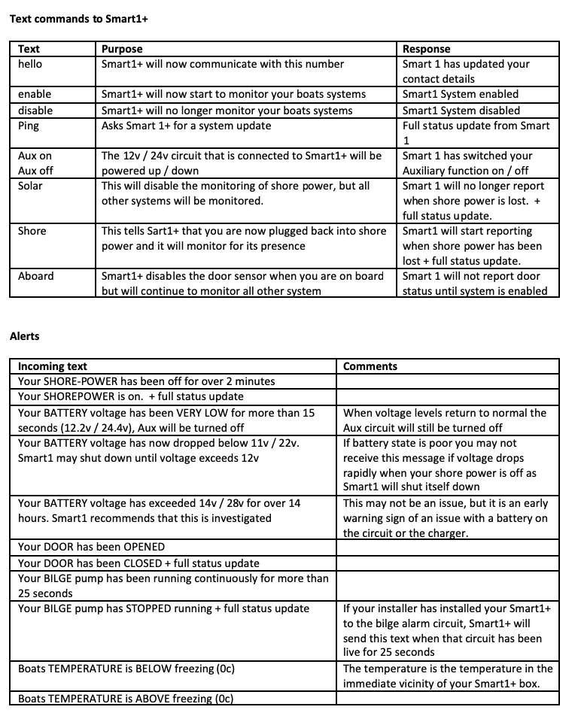

Decision logic in the event of a text alert

During testing of Smart1+ we discovered that some owners were alarmed when they received a text from their boat alerting them to a problem. We therefore created a number of flow charts to guide decision making, at what could be a stressful time. Full definition copies of each of these can be found on our website

Shore Power alert

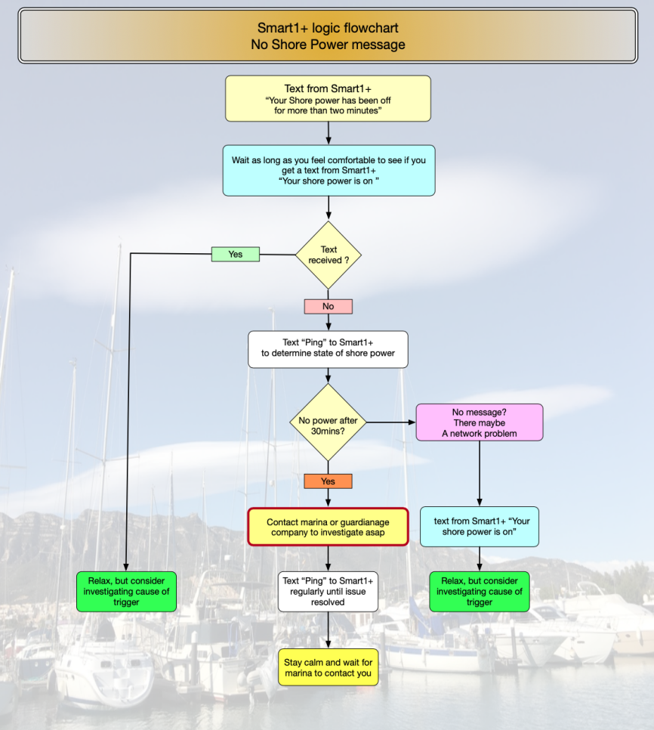

Bilge Alert

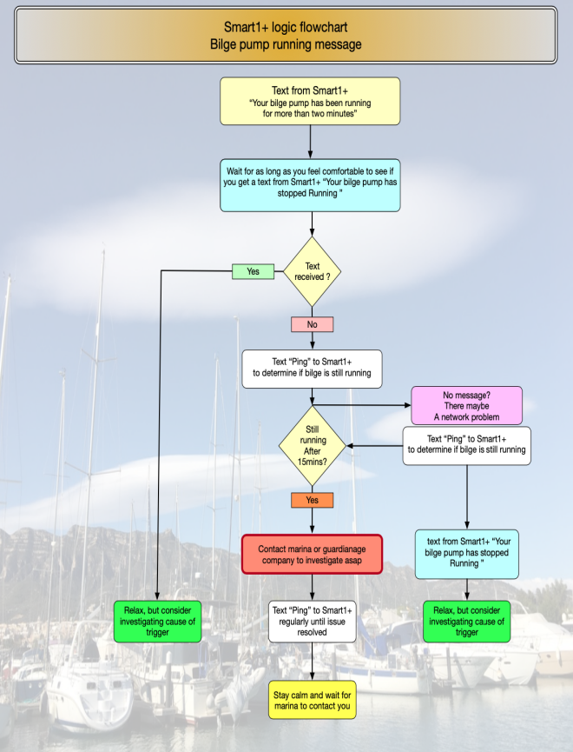

Low Battery voltage alerts

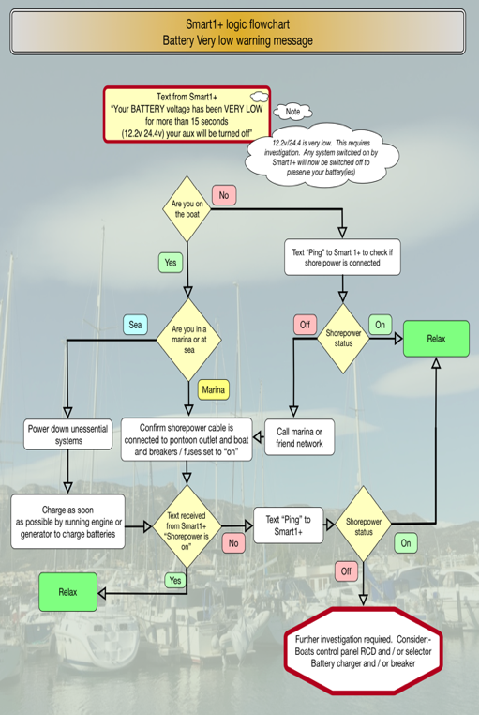

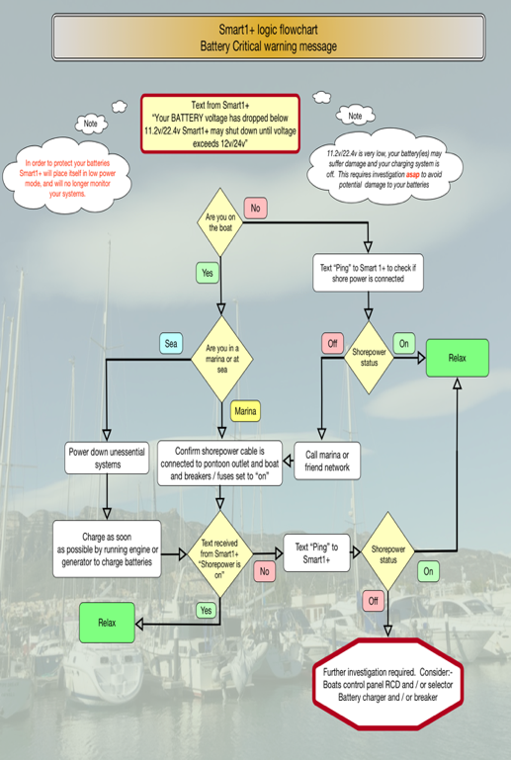

Tems and conditions

See also Digital-Guardianage.co.uk
