Dementia Training & Domiciliary Care provides outstanding training, care and staffing solutions to NHS, Care Homes, Residential homes and other private care facilities to ease the pressure of poor staffing.

We offer specialised (Dementia) and general care training

The arms of our accredited and certificated modules cover:
- Health and safety
- Manual Handling
- Mental Capacity Act
- Heart (Human)
- Mental Health Act 1983 and the reviews
- Fire Safety
- Infection Control
- Skin
- Lungs
- Care of the Disabled (Paraplegia)
- Mental Health Observations
- Risk Assessment
- Pressure Sore/Ulcer Care
- EMDR Skilled Assessment
- Understanding Dementia
- Record & Information Governance
- Basic Life Support
- COSHH
- Epilepsy Awareness
- Brain (Behaviours: Frontal Lobe/Parietal/Occipital &
- Equality & Diversity
- Health & Safety
- Medication Administration
- Fluid & Nutrition

Agency Staffing

Dementia Training & Domiciliary Care provides mental health units and supported living with excellent service.

We have a formidable and stringent recruitment process in place to safeguard all our clients and service users, by which our staff are mandated to comply with. These include:
· Full Employment History – with no Gaps.
Proof of ID
Record of Interview
Evidence of Qualifications and experience
Proof of National Insurance Number
2 Minimum Satisfactory Written Reference
Professional Checks from Regulatory bodies: GMC/HCPC/CIW/NMC/SCE
Enhanced DBS Disclosure
Health Declaration and Immunisation status, including Hepatitis B, Rubella, Tuberculosis and Varicella

. Why work with Us

Dementia Training & Domiciliary Care bears the hallmark of Efficiency, Excellence and Adaptability to change the negative outlook of your staffing level and other work-related challenges in your establishments. Our broad expertise covers:
Care Homes
Hospitals
Residential & People living in the Communities.
Eating Disorder
Dementia
Mental Health (i.e. Substance Misuse)
Personal Care & Promoting Independent Living
Learning Disabilities
People with Physical & Sensory Impairments
People with Spinal & Brain Injuries
Eating Disorder

Accreditation and Memberships:

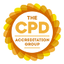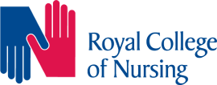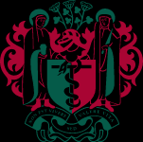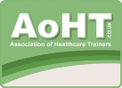
Royal Society of Medicine

