Blue= prepared resource on file  Green= outdoor  Red=needs minor prep | Morning Activity | Afternoon Activity
Monday | - Introduce the topic of British Values – see Own and British Values ppt. Give time to discuss this.  - Literacy: from a selection of images of famous British landmarks – see British Landmarks Images docx, choose place/s they have been in Britain to write words/sentence/s paragraph about. Teacher to choose writing resource eg book or paper. Why or what did they like about it? What could they do there? Add in your own expectations of punctuation and sentence construction standards.  - Extra: If they were to design a new British attraction for families to visit what would it be? Can you show me this made from…..?  - A painting  - A design on Purple Mash (limit on iPads per room)  - Art Straws and glue or tape  - Rolled up newspaper and masking tape | - Now focus on the ‘Rule’ value. Playing games is a simple way to teach children about rules and accountability. Set up games outside opportunity with rules for the children to play (one big game or several small ones). Ask what are the rules? Why are those rules important when we play games? Later discuss what the games would have been like if we had not followed the rules.  - Extra: Children to make their own game outside opportunity with rules which they can write for others.
 | Morning Activities | Afternoon Activities
Tuesday | Focus: Respect & Tolerance - an attitude that recognises and respects the individual choices of others – even if their choices, lifestyle and beliefs are ones you don’t agree with or like.  - EY/KS1: read together 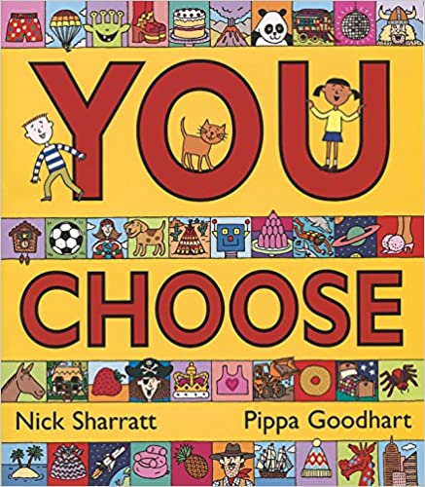Nick Sharratt’s, You Choose (I have a copy). Make sure the children listen to each other’s selections. Take opportunities to praise tolerance of different opinions. Select the most engaging page (house/travel/jobs) and ask the children to write about their choice. Next ask them to write or talk about someone else’s choice but also say why this suits / is good for that person. Illustrate or use other suitable creative demonstration of choice.  or  - KS2 group: Look at holiday brochures (hopefully collect from staff prior). Discuss different holidays they have enjoyed (be sensitive to those with limited travel experiences). Ask the children to design their own holiday – see Holiday Design docx.  Morning Activities | - Share their choices to the class. Praise the class for acknowledging the positives in different selections even if it would not be their choice.  - Play ‘would you rather?’ see Would You Rather Questions docx. Place coloured markers (red/blue/yellow) or similar on opposing walls or on the playground floor, outdoor opportunity. Ask the children a series of age appropriate questions which demand an either/or response. Eg “Would you rather have a pet crocodile (red marker) a pet lion (blue marker) or a pet penguin (yellow marker)?” The children go to one marker or the other to show their choice (you can vary the silliness of questions and how many options). Discuss one or two children’s decisions each time – remember the focus is respect and tolerance.  Afternoon Activities
Wednesday | Focus: Democracy - describes our national electoral system and the skills needed to participate in it successfully.  - Explain the class is going to choose someone to be in-charge for the next day. What should that person be like? Make a list. You may want to watch a speech from a politician as an example of self-promotion. Children can think of powerful and impressive vocabulary to wow their listeners.  - Using their powerful word list, each child can prepare (either verbally or in writing) their pitch to the class. Writing resource book/paper required. | - Ask how will we choose? Discuss different voting options and which is fair?  - Listen to each child’s pitch outside opportunity.  - Carry out a vote with the children counting results. The winner can choose some activities for the class tomorrow.
 | Morning Activities | Afternoon Activities
Thursday | (Don’t forget to let the winner of yesterday’s vote have some responsibility today!)  Focus: Individual Choice (liberty) - is the right of British citizens to make choices regarding the elements of their life that are outside of government control.  Designing something allows children to make choices, think for themselves, and develop independence.  - Set the class a task (they must work independently) to design and make a hat/glasses/friendship bracelet/ school uniform/anything teacher fancies and has resources.  - Allow the children to design their item – ensure this can be completed within the school day. Caption and annotate the making process if age appropriate. Resources needed depending on design task.  Morning Activities | - Children make their planned items. Encourage individual choices which only the child can make.  - Host a gallery exhibition of items or a presentation from the children. Allow them to verbalise their choices and why they made them. Outdoor opportunity.  - Emphasise how it’s important that we do have the freedom (within rules and safety limits) to make our own choices and that the country is richer for it.  Afternoon Activities
Friday | Focus: Display – aim to complete a classroom display by the end of the day. See photo below.  - What have we understood this week? Take photos of the children individually, print then get the children to write in large speech bubbles (younger class may need to be reminded how these work by use of a familiar text) about one of the values this week. Ensure there is the coverage of all 4 values. Promote good penmanship and presentation skills. Display each speech bubble next to the child who wrote it. | 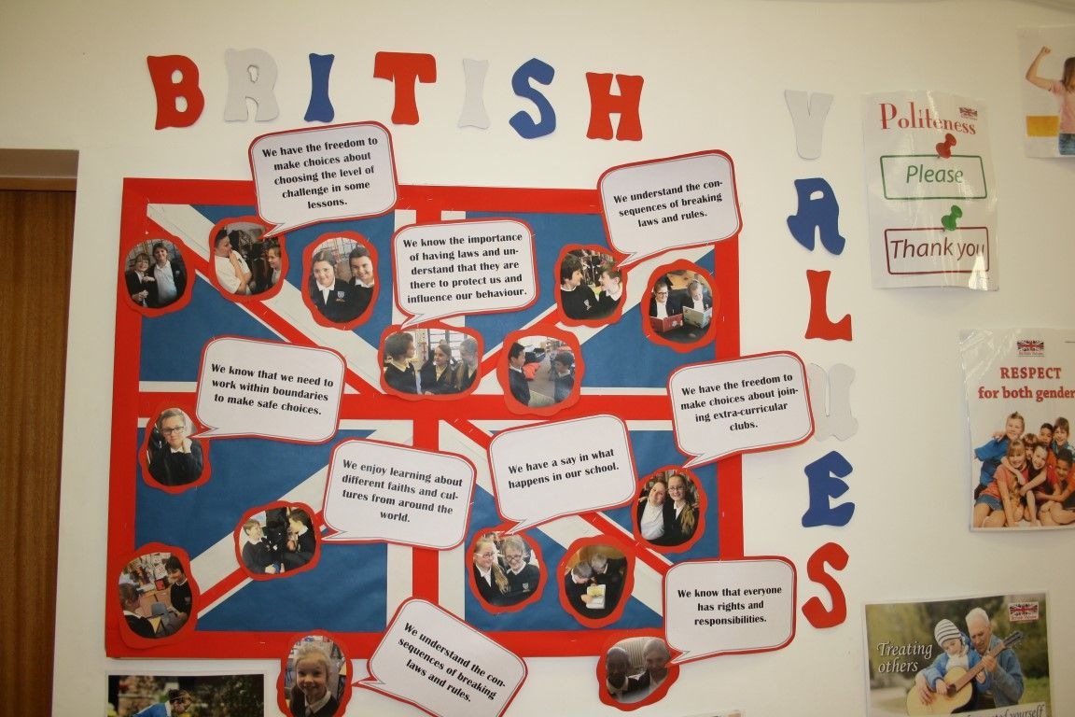  “Let’s work together to make this display this afternoon and show we can all be good British Citizens using our values learned this week.”  Extra: would the children like to play any of the games introduced on Monday or make their own version of someone else’s designed item from Thursday? Outside opportunity.

