Plan What a Wonderful Year
 | YR | Y1 | Y2 |  | Y3 |  |  | Y4 | Y5 | Y6
 | Monday Literacy Look at how much I’ve grown
Reflect on the things you have learnt to do this year. You can choose things you have learnt I school, at home, in a club, anything that you can do now that you couldn’t do in September. Examples: tie my shoe laces, 6 times table, count to 10, read chapter books, write my name, join my handwriting, ride a bike without stabiliser, swim without armbands, etc.
Draw your own flower or print the template.
 | On each petal, draw or write a sentence to show something you have learnt this year. Put your flower together and decorate it. Find somewhere to display your flower. |  | On each petal write a sentence to show something you have learnt this year. Put your flower together and decorate it. Find somewhere to display your flower.
 | Monday Afternoon
 | Make pop art flip flops, use the template in your pack. You could also draw your own. Use bright, bold colours.
 | Tuesday Literacy I’m bored jar
 | Get ready for the summer holidays and make a ‘I’m bored jar’. Write fun activities that you can do by yourself on pieces of paper. Cut them out and put them in a jar. Now you’ll have a jar full of fun activities so whenever you feel bored, go to your jar and choose an activity. Examples, draw a picture, make up a game, set up a teddy bear talent show, write a joke book, make an obstacle course, make a picture using leaves, sticks and stones from your garden, write a letter to a friend, make a card for somebody in your family or a friend, etc.
 | Tuesday Literacy 2: Roll a beach scene
Use the template to roll a beach scene. Draw the sand and sea then roll the dice to work out what you will add to your picture. Start with the towel and roll your way towards the refreshments. For example: one your first roll, if you roll a 3, draw the third towel. If you roll a six for your second roll, draw a play tent.

Write about your picture. Use adjectives to describe what you have drawn.
 | Tuesday Afternoon Make a mini memory book
 | Make a mini memory book. Take the time to decorate your front cover and choose your favourite fabric or draw your own design. Use the same design that we used for the Free To Be Me books: https://www.youtube.com/watch?v=j-eC2AMQolg Tomorrow you will fill your book with your favourite memories from this school year.
 | Wednesday Literacy Memory Book
 | Fill your mini memory book with your favourite memories from this school year. On each page you should draw a picture and write a sentence. Some ideas are: your best friends, your favourite subjects, something you learnt or did in school that you will always remember, something you enjoyed doing, an achievement you are proud of or anything else you can think of.
 | Wednesday Afternoon Make a cocktail card
 | Use the instructions to make a cocktail card. Write a nice message in your card. Put it in an envelope, walk to a postbox and send your car to someone special.  Watch this video to see how they should look: https://www.youtube.com/watch?v=N_gWDr7lM90&feature=share |  |  |  |  | Look at the template and watch the video. Use this to create your own cocktail card.  https://www.youtube.com/watch?v=N_gWDr7lM90&feature=share
 | Thursday Literacy
On Friday afternoon, you can host your own celebration picnic. Today you are going to write an invitation inviting somebody to your picnic to celebrate the end of a wonderful school year. This could be a virtual picnic on Zoom or an actual picnic in your garden. You need to include when the picnic is, what time it starts, where it is and what they should they bring (games, food, drinks, etc.).

Then finish your memory book.
 | Thursday Afternoon Make a handprint ice cream
 | Follow the instructions to make a handprint ice-cream. You will need paint, a black pen, plain paper and brown paper if you have it.
 |  |  | What extra details could you add to your ice cream? Could you add a flake or sauce?
 | Friday Literacy Bucket list
 | Write five things you want to do this summer on the bucket. You could use the picture as a template and make your own bucket and spade. For example: go to the park, eat an ice cream, lean to ride my bike without stabiliser, climb a tree, have a picnic by a river, climb Kinder Scout, etc. Find somewhere to hang your bucket list and every time you do an activity from it, cross it off.
 | Friday Afternoon Picnic
 | Host your own picnic. Help to make the sandwiches and drinks. Why not turn it into a teddy bear’s picnic?

 | Maths Ideas Reception and Year 1 | Maths Ideas Years 2 and 3 | Maths Ideas Years 4, 5 and 6
Monday | Yes/No Game- shape, numbers, things we measure with, units of measure etc.  Choose a card without showing anybody else. The other players must ask yes or no questions to try to guess your card.  Questions: Is it a 2d shape? Is it an odd number? Is the number lower than 10?
Tuesday | Create your own maths puzzles. Can someone in your family/class solve them?  Download more here: https://www.teachingideas.co.uk/addition/junior-emoji-puzzles  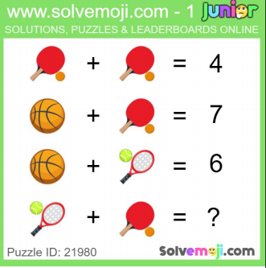 | Create your own maths puzzles. Can someone in your family/class solve them?  Download more here: https://www.teachingideas.co.uk/addition/junior-emoji-puzzles  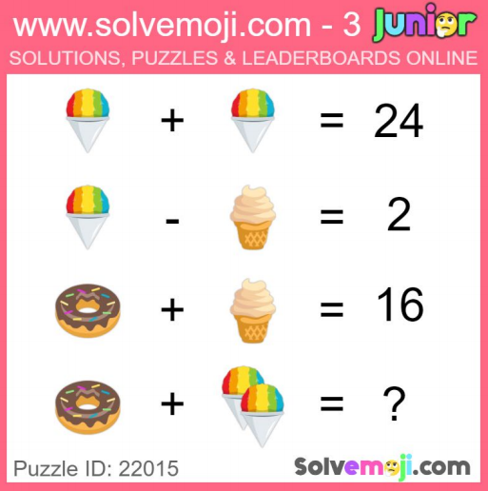 | Create your own maths puzzles. Can someone in your family/class solve them?  Download more here: https://www.teachingideas.co.uk/addition/junior-emoji-puzzles  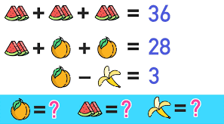  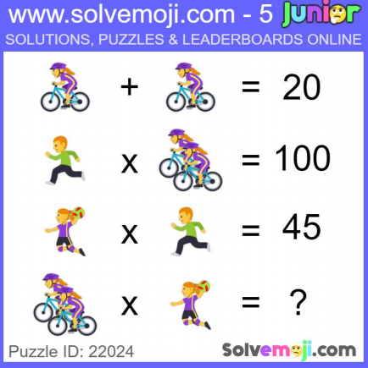
Wednesday | Counting Hop Scotch for YR/1  Use chalk to draw your own hop scotch. In the squares, write numbers 1-10 or for a challenge go up in steps or 2 or 10. As you jump along the hop scotch say the numbers out loud.  If you don’t have chalk, write numbers on a piece of paper or paper plates and arrange them into the shape of a hop scotch game. | Multiplication or Counting Hop Scotch  Multiplication Hop Scotch  Use chalk to draw your own hop scotch. In the squares, write the multiples from a times table. As you jump along the hop scotch say the multiples out loud. For the two times table you would write 2, 4, 6, etc. or 1x2, 2x2, 3x2, etc.  Counting Hop Scotch  Write the numbers from a sequence in the squares on a hop scotch grid. As you jump along the hop scotch say the numbers out loud. You could practise counting in 5s and write 5, 10, 15. You could practise counting in 50s and write 50, 100, 150. You could practise counting in 25s and write 25, 50, 75, 100. You could practise counting in tenths and write, 0.1, 0.2, 0.3, etc.  If you don’t have chalk, write numbers on a piece of paper or paper plates and arrange them into the shape of a hop scotch game. | Multiplication or Counting Hop Scotch  Multiplication Hop Scotch  Use chalk to draw your own hop scotch. In the squares, write the multiples from a times table. As you jump along the hop scotch say the multiples out loud. For the six times table you would write 6, 12, 18, etc.  Counting Hop Scotch  Write the numbers from a sequence in the squares on a hop scotch grid. As you jump along the hop scotch say the numbers out loud. You could practise counting in negative numbers and start with -9, -8 up to 0. You could practise counting in decimals and write 0.25, 0.5, 0.75, etc. You could practise Roman numerals or any other type of counting.  If you don’t have chalk, write numbers on a piece of paper or paper plates and arrange them into the shape of a hop scotch game.
Thursday | Measure Scavenger Hunt  Use the template to go on a scavenger hunt. If you don’t have a printer, you could draw this.  If you can’t do this in school, you could choose a game from Math 4 Kids:  https://www.youtube.com/playlist?list=PLWIJ2KbiNEyoBDc5yLJ4PaiaY3o5E5xCB
Friday | Choose a game from Maths 4 Kids  https://www.youtube.com/playlist?list=PLWIJ2KbiNEyoBDc5yLJ4PaiaY3o5E5xCB  There is a mixture of individual, pairs and group games. My class have already played a lot so I’m going to let them choose.

