SECTION 1 PART A - IDENTIFICATION DETAILS
Sire
Name of
Head (Tete)

Colour/ Robe
Name of Animal/ Nom
Sex/ Sexe
Date of Birth
Dam
Neck (Cou)

Left Hind (PG)
Hind Limbs
Fore Limbs
Left Fore (AG)

Right Hind (PD)
Right Fore (AD)

Acquired Marks
Body (Corps)

Were these markings taken from the foal prior to weaning YES NO

SECTION 1 PART B – OUTLINE DIAGRAM
Transponder
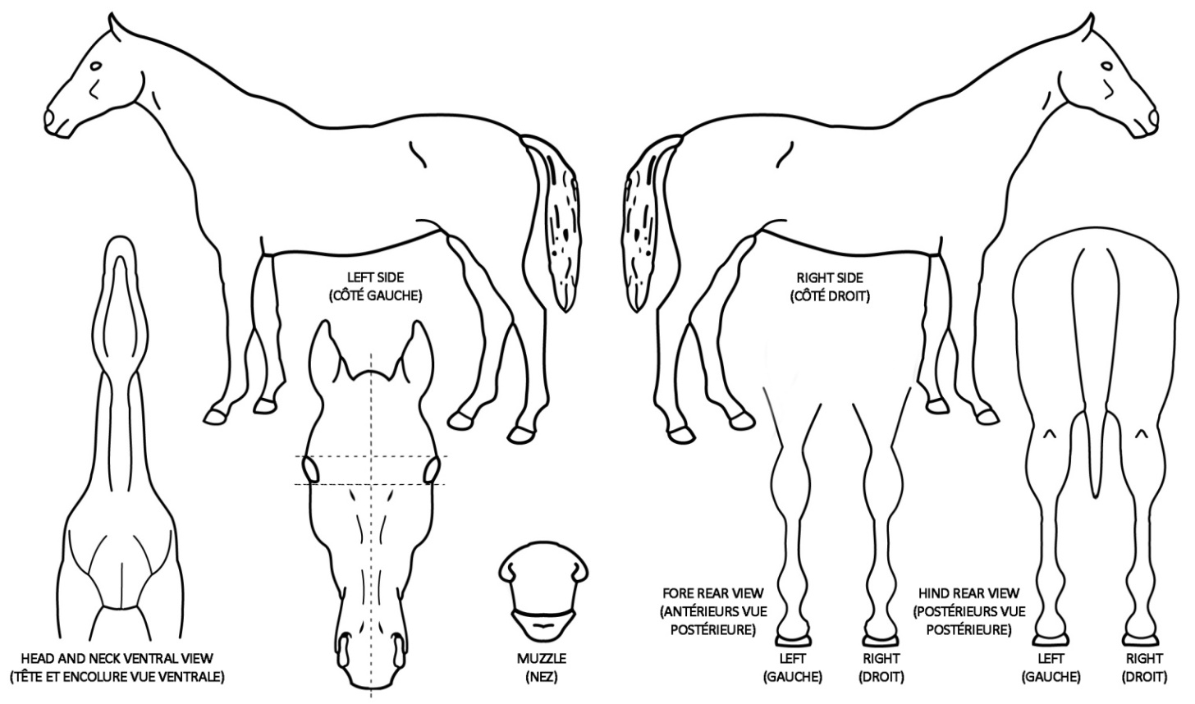
Signature and Stamp of Veterinary Surgeon or Competent Authority
Signature et cachet chi veterinaire agree (ou de l’autoright copetente)
PLACE AND DATE OF IDENTIFICATION (Circonscription et date)
…………………………………………………………………………………..…………..……………………………………………………..………Date……………………………………………………………………………………………………………..………………………………………..….
…………………………………………………………….………………Date………………………………………………

