St Andrew’s
Scottish Episcopal Church
Kelso

A QUIET CHRISTMAS
Thursday 20th December at 5.00 pm
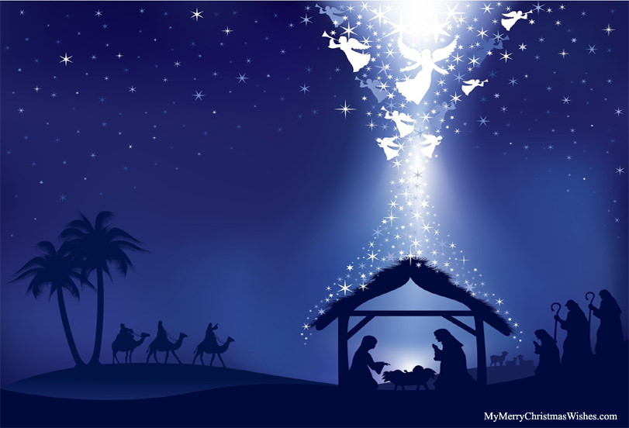

Come and join us for a
Quiet Celebration of Christmas
with Carols, Readings, Reflection and Music.

A Christmas Service for those who prefer a Gentle Celebration

Belmount Place Kelso TD5 7JB

